You have n processes forming a rooted tree structure. You are given two integer arrays pid and ppid, where pid[i] is the ID of the ith process and ppid[i] is the ID of the ith process's parent process.

Each process has only **one parent process** but may have multiple children processes. Only one process has ppid[i] = 0, which means this process has **no parent process** (the root of the tree).

When a process is **killed**, all of its children processes will also be killed.

Given an integer kill representing the ID of a process you want to kill, return *a list of the IDs of the processes that will be killed. You may return the answer in****any order****.*

**Example 1:**

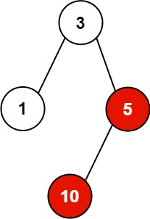

**Input:** pid = [1,3,10,5], ppid = [3,0,5,3], kill = 5

**Output:** [5,10]

**Explanation:** The processes colored in red are the processes that should be killed.

**Example 2:**

**Input:** pid = [1], ppid = [0], kill = 1

**Output:** [1]

**Constraints:**

* n == pid.length
* n == ppid.length
* 1 <= n <= 5 * 104
* 1 <= pid[i] <= 5 * 104
* 0 <= ppid[i] <= 5 * 104
* Only one process has no parent.
* All the values of pid are **unique**.
* kill is **guaranteed** to be in pid.